**Project Planning Phase**

**Project Planning Template (Product Backlog, Sprint Planning, Stories, Story points)**

| Team ID | PNT2022TMID31901 |
| --- | --- |
| Project Name | Project – Estimate the crop yield using Data Analytics |
| Maximum Marks | 8 Marks |

**Product Backlog, Sprint Schedule, and Estimation (4 Marks)**

| **Sprint** | **Functional Requirement (Epic)** | **User Story**  **Number** | **User Story / Task** | **Story Points** | **Priority** | **Team Members** |
| --- | --- | --- | --- | --- | --- | --- |
| Sprint-1 | Registration | USN-1 | As a user, I can register for the application by entering my email, password, and confirming my password. | 2 | High | Abhinav P  Ashifa N |
| Sprint-1 |  | USN-2 | As a user, I will receive confirmation email once I have registered for the application | 1 | High | Inbasekaran A  Sabitha P |
| Sprint-2 |  | USN-3 | As a user, I can register for the application through Google | 2 | Low | Abhinav P  Sabitha P |
| Sprint-1 |  | USN-4 | As a user, I can register for the application through Gmail | 2 | Low | Ashifa N  Inbasekaran A |
| Sprint-1 | Login | USN-5 | As a user, I can log into the application by entering email & password | 1 | High | Abhinav P  Inbasekaran A |
| Sprint- 3 | Dashboard | USN-6 | As a user, I can freely use my dashboard and explore the features | 2 | High | Ashifa N  Sabitha P |
| Sprint- 2 |  | USN-7 | As a user, I can use the credentials to access the resources of my application | 2 | High | Abhinav P  Sabitha P |
| Sprint- 3 |  | USN-8 | Performance of Data manipulations on the application | 1 | High | Ashifa N  Inbasekaran A |
| Sprint- 3 | Visualizations | USN-9 | I can create dashboards with particular datasets | 2 | High | Abhinav P  Ashifa N |
| Sprint- 4 |  | USN-10 | Predictive analysis can be done | 1 | High | Inbasekaran A  Sabitha P |
| Sprint- 3 |  | USN-11 | I can create stories with particular datasets | 2 | High | Abhinav P  Inbasekaran A |
| Sprint- 4 |  | USN-12 | I can deliver and export reports according to the dashboards and stories created | 2 | High | Ashifa N  Sabitha P |

**Project Tracker, Velocity & Burndown Chart: (4 Marks)**

| **Sprint** | **Total Story**  **Points** | **Duration** | **Sprint Start Date** | **Sprint End Date**  **(Planned)** | **Story Points**  **Completed (as on Planned End Date)** | **Sprint Release Date**  **(Actual)** |
| --- | --- | --- | --- | --- | --- | --- |
| Sprint-1 | 20 | 6 Days | 24 Oct 2022 | 29 Oct 2022 | 20 | 29 Oct 2022 |
| Sprint-2 | 20 | 6 Days | 31 Oct 2022 | 05 Nov 2022 | 20 | 05 Nov 2022 |
| Sprint-3 | 20 | 6 Days | 07 Nov 2022 | 12 Nov 2022 | 20 | 12 Nov 2022 |
| Sprint-4 | 20 | 6 Days | 14 Nov 2022 | 19 Nov 2022 | 20 | 19 Nov 2022 |

**Velocity:**

Imagine we have a 6-day sprint duration, and the velocity of the team is 20 (points per sprint). Let’s calculate the team’s average velocity (AV) per iteration unit (story points per day)

AV = Sprint Duration/Velocity = 20/6 = 3

**Burndown Chart:**

A burn down chart is a graphical representation of work left to do versus time. It is often used in agile software development methodologies such as Scrum. However, burn down charts can be applied to any project containing measurable progress over time.

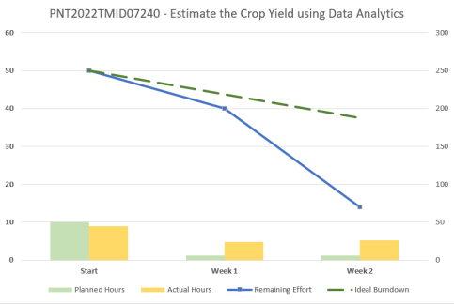

**https://www.visual-paradigm.com/scrum/scrum-burndown-chart/**

**https://www.atlassian.com/agile/tutorials/burndown-charts**

**Reference:**

**https://www.atlassian.com/agile/project-management**

**https://www.atlassian.com/agile/tutorials/how-to-do-scrum-with-jira-software https://www.atlassian.com/agile/tutorials/epics**

**https://www.atlassian.com/agile/tutorials/sprints**

**https://www.atlassian.com/agile/project-management/estimation https://www.atlassian.com/agile/tutorials/burndown-charts**